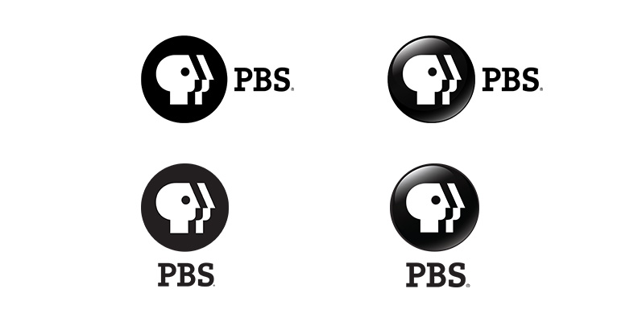

# Public Media Part 5 - Reusable Metadata version RC-4

This Enterprise Metadata Model (EMM) is the basis for how commonly interchanged metadata is structured and validated in Public Broadcasting. The EMM uses the Entertainment Identifier Registry as its standard. The EMM builds its schema upon the experience of MovieLabs and Gracenote, respectively. The purpose of the EMM is to improve interoperability for Public Media content. The current version is 2.1﻿﻿. Release Candidate #4﻿ is pending.

Released date: pending  
Document URL: pending

Table of Contents

Public Media Part 5 - Reusable Metadata version RC-2 1

3 Introduction 3

3.1 Selected Metadata Standard and Schemas 3

3.2 Namespaces 3

Version Control 4

4 Reusable Metadata Entities 5

4.1 Organization 6

4.1.2 Organizations Structural Relational Metadata 7

4.1.3 Entity = md:Org 7

4.1.4 Elements = md:Org 8

4.2 Credits 11

4.2.1 Structural Metadata for Credits 11

4.2.2 Entity = md:ContactInfo-type 11

4.2.3 Entity = md:ContactInfo-type 12

4.3 Use Window Metadata 13

4.3.1 Entity = pm-reuse:UseWindow 13

4.3.2 Elements = pm-reuse:UseWindow 14

5 Data Dictionary 15

6 Required fields within the Data Model 17

6.1 Organization Required Fields 17

6.2 Credits Required Fields 17

# Introduction

The Public Media Enterprise Metadata Application Profile (MAP) is a metadata schema to improve interoperability across Public Media show products.

This MAP supports the foundational metadata necessary to locate Public Media show products while:

* Browsing a Member Station website
* Identifying show files
* A viewer browses OTT listings
* A viewer browses cable MSO listings
* Planning a program lineup
* Locating a show in traffic software
* A Viewer Services representative seeks to identify a show for a viewer

The MAP does not support specific refinements any one initiative or project. The creation of secondary application profiles is encouraged to extend this MAP for any one specific need.

## Selected Metadata Standard and Schemas

There is no one industry schema; there are the most preferred schemas – each have a distinct focus. The Public Media Reusable Metadata MAP aligns to:

* **MovieLabs Common Metadata Specification**  
  MovieLabs is a Digital Distribution Framework that defines standards for online distribution, automation of digital workflows and supply chain efficiency to improve consumer experiences.

## Namespaces

Namespaces define a logical reference that maps back to a schema’s source. Public Media MAP references the aforementioned schemas in its framework. In order to claim compliance with this specification, it is necessary to conform to the following standards and other works as indicated, in addition to the other requirements of this specification. Notwithstanding, intellectual property rights may be required to use or implement such normative references.

|  |  |  |
| --- | --- | --- |
| Schema | Namespace | |
| Entertainment Registry Identifier | [eidr] | http://www.eidr.org/schema/2.0 |
|  |  | http://eidr.org/documents/EIDR_2.0_Data_Fields.pdf |
| MovieLabs Common Metadata2.5 | [md] | http://movielabs.com/md/md/ |
| Public Media Common Metadata 3.0 | [pm-reuse] |  |

# Version Control

|  |  |  |  |
| --- | --- | --- | --- |
| Revision ID | Date | Editor | Action |
| RC-1 | 4/5/2016 | Edgar Roman |  |
| RC-2 | 4/11/2016 | Edgar Roman |  |
| RC-3 | 4/29/2016 | Edgar Roman | Parts 1 & 2 were published in draft |
| 1.0 | 5/16/2016 | Edgar Roman | Parts 1 & 2 were published |
| RC-4 | 4/20/2018 | Rachelle Byars-Sargent | Added the new entity, Use Window  Aligned the Credits entity to MovieLabs  Aligned the Organization entity to Movielabs. |

# Reusable Metadata Entities

Entities provide systems to manage records. Entities support the records perspective for understanding the business domain but they are not in themselves always tangible objects.

Catalog Content

* Organization (required for Series and Episode)
* Credits (required for Series and Episode)

Access

* Use Window (required for Manifestation)

## Organization

This identifies an organization. Organizations can be used as a means to identify contractual relationships, such as Copyright Holder. Organizations may also be used to capture talent and credits.

Organizations and Credits are business concepts that can be associated with any EMM entity.

The basic relationships between Organizations, Credits, and the abstract content models are described in Figure 2.

#### Figure 2: Metadata Relationships Between Organizations, Content, and Credits

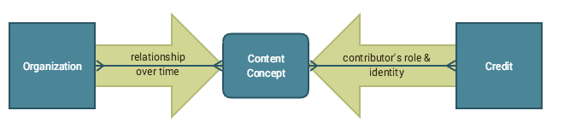

Once registered, an Organization contains metadata describing its relationship to a content concept over time. Similarly, a Credit contains metadata that identifies a contributor and describes the contributor’s specific role in relation to a content.

Many Organizations and Credits can be associated with one content concept, and Organizations can be associated with various pieces of content. Figure 3 illustrates these possibilities.

#### Figure 3: Example of Multiple Content Concepts, Organizations, and Credits

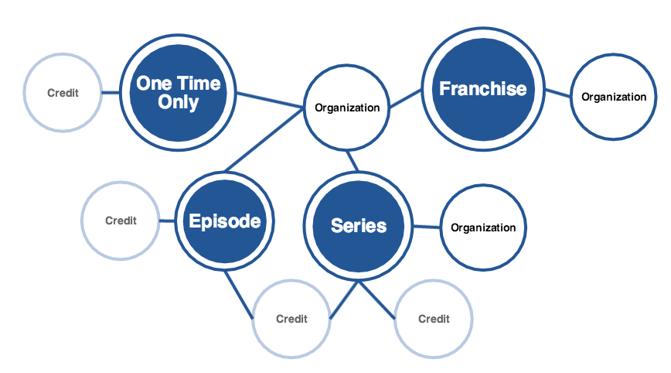

This web illustrates how Credits and Organizations can be associated with multiple content concepts.

### Organizations Structural Relational Metadata

An Organization is some business entity with a role in content distribution, such as a Distributor, a Station, or a Producer. These Organizations may have some information like contact information and mailing addresses that would be useful to associate with content for legal reasons and planning.

|  |  |
| --- | --- |
| **Relationship** | **Description** |
| isAssociatedWith | Organization metadata should be associated with a Compilation, Series, Season, Episode/One-Time-Only, Manifestation, or File. |

### Entity = md:Org

### Elements = md:Org

#### Setup for New Organization

During the Acquisition phase of a production, a CRM administrator should register new Organizations in a central metadata system with the following information:

|  |  |  |  |  |
| --- | --- | --- | --- | --- |
| **Element Name** | **Input Guidelines** | **Examples:** | **Cardinality** | **Obligation** |
| Organization@orgID | A Distributors unique ID for internal tracking . | OrgID:xxxx-xxxx-xxxx | 0 | Conditionally Required if Display Name is blank. |
| Organization@domain | The organization's domain name. NOTE: If domain is EIDRPartyID, organization must be a valid EIDR Party ID. | ISAN,TVG,AMG,IMDB,MUZE,TRIB,URI,EIDR,Grid, etc. | 1 | Required |
| Organization/DisplayName | A company associated with the work, preferably a list of the producers, distributor or else the original commissioning broadcaster. | NETA, APT | 1…n | Conditionally Required when OrgID is not provided. |
| Organization/Contact Info/Phone | The best phone number to reach the Contact or Organization. | +14155552671 | 1 | Required |
| Organization/Contact Info/Phone@Type | A mechanism to identify a number's utility. | Main, Mobile, Fax, Other, Office | 1 | Main is Required. |
| Organization/Contact Info/Address | The physical address of the Organization’s headquarters. | 0 | 0 | 0 |
| Organization@role | A mechanism to identify the role of the organization as it relates to the work. | Producer, Broadcaster, Distributor, Editor, Encoding, Post-Production, Licensor, Other | 1…n | 0 |
| Organization/Contact Info/PrimaryEmail | Primary email address for contact. | 0 | 1 | 0 |
| Organization/Contact Info/Name | Use when the contactID is blank. Display name of primary contact. | "Joe Doe" | 1 | 0 |
| Organization/Contact Info/contactID | If an existing contact is reused, provide the contactID and leave the remaining contact fields blank.The Distributor's assigned contactID. | 0 | 0 | Conditionally Required if Name is not provided. |

## 

## Credits

Credits tell the identity and role of someone who contributed to content. For example: Hosted by John Smith.

Multiple Credits can be added to a piece of content.

### Structural Metadata for Credits

|  |  |
| --- | --- |
| **Relationship** | **Description** |
| ContributedTo | Can be associated to Series, Season, or Episode. |

### Entity = md:ContactInfo-type

### Entity = md:ContactInfo-type

#### Some Credit metadata may be known at the Acquisition stage, such as Producer and Director. However, a comprehensive Talent list typically is known toward the end of Production. Once the contact profile is set up, it can be associated to a role.

|  |  |  |  |  |
| --- | --- | --- | --- | --- |
| **Element Name** | **Input Guidelines** | **Examples:** | **Cardinality** | **Obligation** |
| Credits@TalentId | The Distributor's assigned UID for the cast or crew prefaced by the Distributor's domain. | XXXX-XXXX-XXXX-XXXX-XXXX | 1..n | Conditionally Required. |
| Credits@role | Producer and Distributor are required.A name of cast or crew associated with the work.  Credits tell the identity and role of someone who contributed to a Series, Episode, OTO, or Story. For example: Directed by John Smith. Some Credit metadata may be known at the Acquisition stage, such as Producer and Director. However, a lot of the Credit metadata cannot be filled in for sure until the end of Production. Multiple Credits can be added to a piece of content. | Writer, Director or Producer | 1 | Required |
| Credits/Display Name | A name of cast or crew associated with the work.  Credits tell the identity and role of someone who contributed to a Series, Episode, OTO, or Story. For example: Directed by John Smith. Some Credit metadata may be known at the Acquisition stage, such as Producer and Director. However, a lot of the Credit metadata cannot be filled in for sure until the end of Production. Multiple Credits can be added to a piece of content. | "Joe Doe" | 1..n | Conditionally Required when TalentID is not provided. |

## Use Window Metadata

A use window reflects a limited term within another rights term.

For example, an episode may have product placement within the essence for the month of November.  After which, the main edit is used for the remainder of the rights term.

Another example:

Within each EMM entity, supplemental content (underwriting, system cues, brand spots, teasers) may have limited rights windows due to popular music tracks or high-profile talent, for example. When supplemental content is combined into a playable sequence, the final manifestation may have a more narrow usage term, than the storyline rights.

A usage term is calculated by identifying the rights windows for each element – including the feature presentation – within a Manifestation.   From which, the lowest start and end dates combine to derive a usage term.

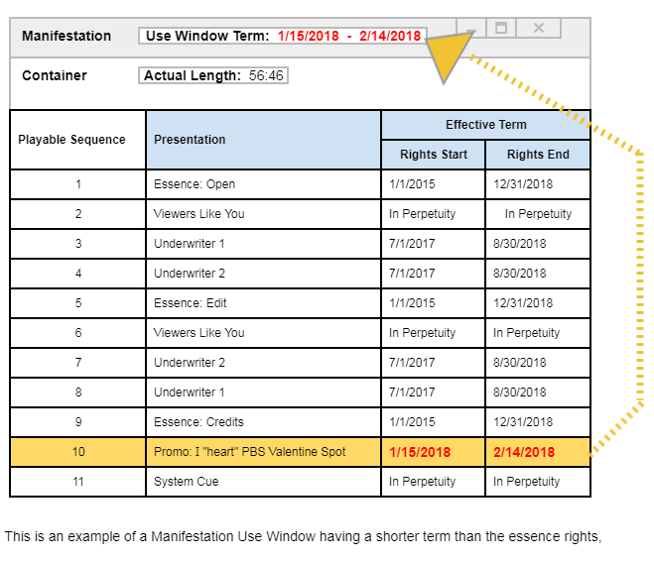

### Entity = pm-reuse:UseWindow

### Elements = pm-reuse:UseWindow

|  |  |  |  |  |  |
| --- | --- | --- | --- | --- | --- |
| **Data Object** | **Element Name** | **Input Guidelines** | **Examples:** | **Cardinality** | **Obligation** |
| UseWindow/Term | Functional | A use window reflects a limited term caused either by supplemental media or c hanges within an essence, which impacts the larger rights term. | "2017-10-10T14:22:15Z":"2017-12-10T14:22:15Z" | 0…n | 0 |

# Data Dictionary

|  |  |  |  |
| --- | --- | --- | --- |
| **Element Name** | **Element Category** | **Input Guidelines** | **Examples:** |
| Organization/Contact Info/Address | Administrative | The physical address of the Organization’s headquarters. | 123 Oak Street, Wellington, OH 12345 |
| Organization/Contact Info/contactID | Administrative | The Distributor's assigned contactID. | xxx-xxx-xxx |
| Organization/Contact Info/Name | Administrative | Display name of primary contact. | John Smith |
| Organization/Contact Info/Phone | Administrative | The best phone number to reach the Contact or Organization. | +14155552671 |
| Organization/Contact Info/Phone@Type | Administrative | A mechanism to identify a number's utility. | Main, Mobile, Fax, Other, Office |
| Organization/Contact Info/PrimaryEmail | Administrative | Primary email address for contact. | johnsmith@email.com |
| Organization/DisplayName | Administrative | A company associated with the work, preferably a list of the producers, distributor or else the original commissioning broadcaster. | National Education Television Association, American Public Television, Public Broadcasting System |
| Organization@domain | Administrative | The organization's domain name. NOTE: If domain is EIDRPartyID, organization must be a valid EIDR Party ID. | NETA,APT,PBS,ISAN,TVG,AMG,IMDB,MUZE,TRIB,URI,EIDRPartyID,Grid, etc. |
| Organization@orgID | Administrative | A Distributors unique ID for internal tracking . | orgid:xxx-xxx-xxx |
| Organization@role | Administrative | A mechanism to identify the role of the organization as it relates to the work. | Producer, Broadcaster, Distributor, Editor, Encoding, Post-Production, Licensor, Other |
| Credits/Display Name | Descriptive | A name of cast or crew associated with the work.  Credits tell the identity and role of someone who contributed to a Series, Episode, OTO, or Story. For example: Directed by John Smith. Some Credit metadata may be known at the Acquisition stage, such as Producer and Director. However, a lot of the Credit metadata cannot be filled in for sure until the end of Production. Multiple Credits can be added to a piece of content. | "Joe Doe" |
| Credits@role | Administrative | A mechanism to identify the role of the cast or crew as it relates to the work. | Actor, Moderator,Analyst, Music Director,Anchor, Musician,Animal, Actor,Narrator,Animation, Panelist, Announcer, Performer,Appearing, Photographer, Art Director, etc |
| Credits@TalentId | Descriptive | The Distributor's assigned UID for the cast or crew prefaced by the Distributor's domain. | pbs:xxx-xxx-xxx |
| UseWindow/Term | Functional | A use window reflects a limited term caused either by supplemental media or c hanges within an essence, which impacts the larger rights term. | "2017-10-10T14:22:15Z":"2017-12-10T14:22:15Z" |

# Required fields within the Data Model

## Organization Required Fields

|  |  |  |
| --- | --- | --- |
| **Element Name** | **Input Guidelines** | **Examples:** |
| Organization@orgID | A Distributors unique ID for internal tracking . | OrgID:xxxx-xxxx-xxxx |
| Organization@domain | The organization's domain name. NOTE: If domain is EIDRPartyID, organization must be a valid EIDR Party ID. | ISAN,TVG,AMG,IMDB,MUZE,  TRIB,URI,EIDR,Grid, etc. |
| Organization/DisplayName | A company associated with the work, preferably a list of the producers, distributor or else the original commissioning broadcaster. | NETA, APT |

## Credits Required Fields

|  |  |  |
| --- | --- | --- |
| **Element Name** | **Input Guidelines** | **Examples:** |
| Credits@TalentId | The Distributor's assigned UID for the cast or crew prefaced by the Distributor's domain. | XXXX-XXXX-XXXX-XXXX-XXXX |
| Credits/Display Name | A name of cast or crew associated with the work.  Credits tell the identity and role of someone who contributed to a Series, Episode, OTO, or Story. For example: Directed by John Smith. Some Credit metadata may be known at the Acquisition stage, such as Producer and Director. However, a lot of the Credit metadata cannot be filled in for sure until the end of Production. Multiple Credits can be added to a piece of content. | "Joe Doe" |